1. Which are the top three variables in your model which contribute most towards the probability of a lead getting converted?

**Solution:** Based on the coefficient values from below screeshot, the following are the top three variables that contribute most towards the probability of a lead getting converted :

1. Total Visits
2. Total Time Spent on Website
3. Lead Add Form (from Lead Origin)

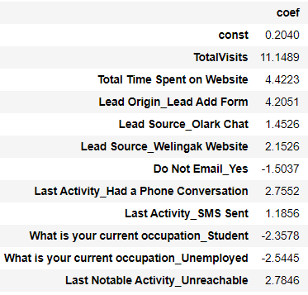

1. What are the top 3 categorical/dummy variables in the model which should be focused the most on in order to increase the probability of lead conversion?

**Solution**: Again, based on the coefficient values from the screen shot in the question above, the following are the top three categorical/dummy variables that should be focused the most in order to increase the probability of lead conversion :

1. Lead Add Form (from Lead Origin)
2. Had a Phone Conversation ( from Last Notable Activity)
3. Unreachable ( from Last Notable Activity)
4. X Education has a period of 2 months every year during which they hire some interns. The sales team, in particular, has around 10 interns allotted to them. So during this phase, they wish to make the lead conversion more aggressive. So they want almost all of the potential leads (i.e. the customers who have been predicted as 1 by the model) to be converted and hence, want to make phone calls to as many of such people as possible. Suggest a good strategy they should employ at this stage.

**Solution :** One strategy can be to use efficient CRM tools like salesforce which enables to manage the communications(sms/email/voice calls) with all the customers at one place . On top of this we can adopt certain good practices like calling the leads/ potential - customer at their preferred time which would further assist in the lead nurturing process .

1. Similarly, at times, the company reaches its target for a quarter before the deadline. During this time, the company wants the sales team to focus on some new work as well. So during this time, the company’s aim is to not make phone calls unless it’s extremely necessary, i.e. they want to minimize the rate of useless phone calls. Suggest a strategy they should employ at this stage.

**Solution:** In this case one strategy can be rolling out a survey whether the interested people would like to receive a callback from X education . Interested folks can leave their contact details and preferred timing , so instead of calling each and everyone the company can call only the interested people .